Using IDistributed Cache with EF Core
Bert O’Neill
Department: | Code Project - IT\Software Support
Document Title: | IDistributed Cache and EF Core – Coding Examples
Author: | Bert O’Neill
Date: | 07-July-2024
Version | 1.0
Email | Bert.ONeill@Yahoo.com
Document Goals | Providing a detailed overview of using IDistributed Cache to improve the performance of your EF Core queries, against On-Premise caching systems like Redis, NCache, SqlCache, MySqlCache and API Output caching.

Revision History

Date | Version | Description | Author
07-July-2024 | 1.0 | Initial draft | Bert O’Neill

Contents
Revision History 1
Introduction 3
Purpose 3
Scope 3
Prerequisites 3
Blog Files 3
SQL Script 3
Visual Studio Solution (Projects x3) 3
EF Core Interceptor Class 3
Setting up Test Database 4
Benchmarks (Seconds) 5
Add Interceptor Using NuGet Package OR Add Class Directly into Your Project 6
Add Interceptor Class Uinsg NuGet Package 6
Add Interceptor Class Directly 8
Edit Entity Framework Core Settings to Call Custom Interceptor Middleware 9
Program.cs Class 9
Your dbContext Class 9
Interceptor Code Explanation 10
ReaderExecutingAsync | ReaderExecuting 10
Helper Classes 10
ConvertInClauseToOpenJson 10
ConvertToOpenJson 11
Examples of the Original EF SQL and the Generated OpenJson SQL 12
Varchar Example 12
Integer Example 12
How to Collate Results Using Multithreading and ConcurrentBag 14
Miscellaneous 15
Acronym 15

Introduction
This document provides an overview on how to configure various (On-Premise) caching systems and integrate them with your Entity Framework Core queries, to improve the performance through-put and alleviate unnecessary database (select) calls.

Purpose
Your solution maybe in a situation, where you now need to scale up, or move away from an in- memory caching approach (for e.g. IMemoryCache) to a more robust, production grade caching system. One that will allow you to add extra nodes to your cluster when needed, or keep the integratory of your data, after a server reboot, or replicate your cached data across multiple locations.

Scope
The scope of this document is to quickly convey the configuration steps for the caching system, but more importantly how to use them with .Net Core and not compromise the SOLID principal, if you switch caching mechanism in the future (your services still inherit from IDistributedCache).

Prerequisites
- An understanding of SQL
- An understanding of (Microsoft’s) Entity Framework Core
- An understanding of EF Core
- An understanding on caching terminology
- Install SQL Server (Developer Edition) (if running attached code against Sql Server).
- Install MySQL Workbench (if running attached code against MySql)
- Install Visual Studio 22 Community.

SQL Script

Visual Studio Solution

Project Structure
Below, you can see the solution layout, with multiple projects per Caching System. This is to run multiple requests at the same time, but one server will find that the cache is empty (cache miss), then query the database and populate it. The second server call will find data in the cache (cache hit) and return that without going to the database.
There is only one project for the Response Output Caching example, as the data is cached on the respective server (not at the distributed caching system). So, a second server API call with Response Output Caching will not know about the first server’s cache. But I have included it as I believe it is a good mechanism to use in conjunction with a distributed caching system.
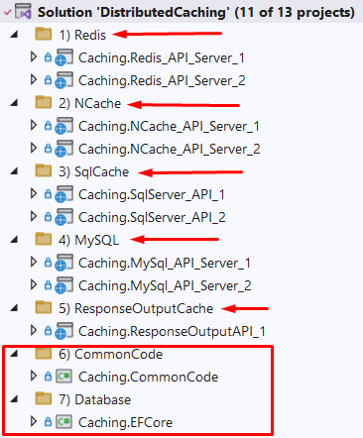

Caching Systems Implemented & Setup (On-Premise)

Redis
NCache
SqlCache
MySqlCache
Response Output

Setting up Test Database

Run the following SQL script to:
- Create a new test database called LinqPerformanceDemo
- Create a new table called LargeTable
- Insert 1 million records into the table LargeTable
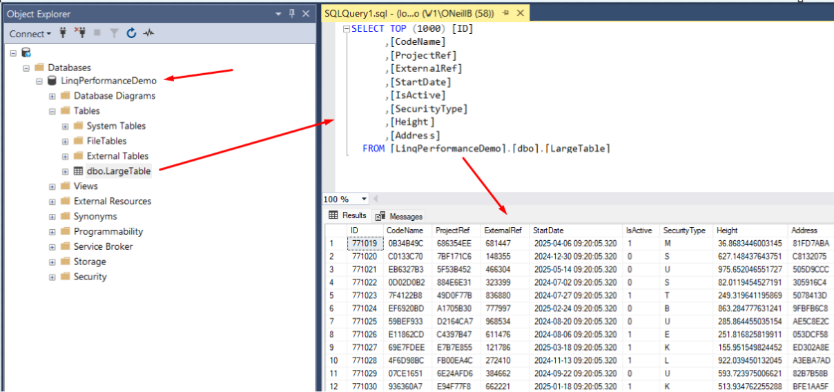

Benchmarks (Seconds)
Using a simple LINQ statement with a large IN clause and a small NOT IN Clause:
context.LargeTables.Where(itm => chunkData.Contains(itm.CodeName) && !_listNotIn.Contains(itm.ProjectRef)).ToListAsync();

In Clause - Batch Size | Standard EF Settings | OpenJson EF Interceptor
20K | 151 | 234
30K | 396 | 157
40K | Timeout | 132
100K | Timeout | 123
150K | Timeout | 99
200K | Timeout | 98
300k | Timeout | 91
500k | Timeout | 83
700K | Timeout | 86
1M | Timeout | 105

At 40K, standard EF failed with a timeout on the first IN clause:
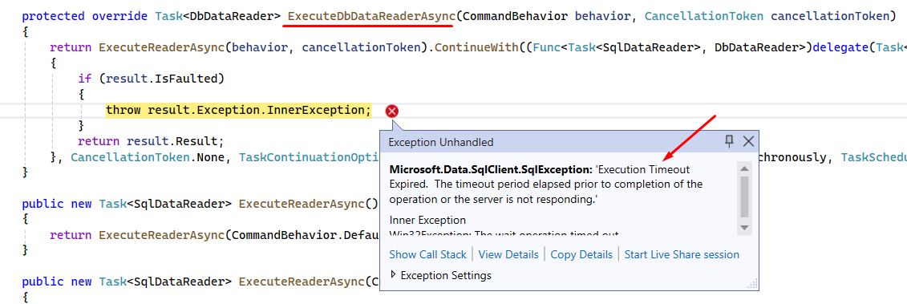
NB: The Entity Framework SQL query generator will very often create SQL statements that are complex and convoluted, especially when there is an IN\NOT IN clause involved. It will duplicate the clause with any joined tables that need to match on your values. This can often make the query fail, as SQL Server is unable to execute it, due to its complexity. But with OpenJson you can get around that issue – by using a larger number of values within your chunking approach, and multithreading with concurrent bags to maintain your results (I’ll show example code later).

Add Interceptor Using NuGet Package OR Add Class Directly into Your Project

Add Interceptor Class Uinsg NuGet Package
The NuGet package is located here on Nuget.Org, with the Readme.md file on how to edit the EF settings within your project – choose the latest version to install.

You can add the NuGet package within Visual Studio like a normal package, into your project – search for Linq.OpenJson.InClause.Middleware and click install.
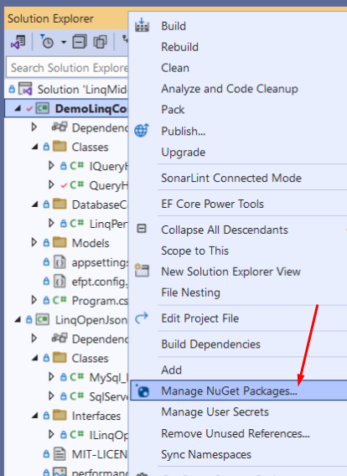

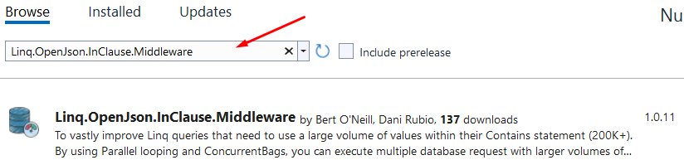

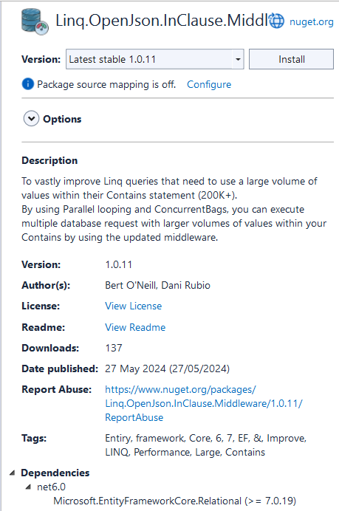

Add Interceptor Class Directly
If you open the attached Visual Studio solution you will see three projects, the project named DemoLinqContainsOpenJson is to demo and test the new EF interceptor.
The second project called LinqOpenJsonInClauseMiddleware, is the NuGet package contents and contains the interceptor override methods (ReaderExecutingAsync and ReaderExecuting).
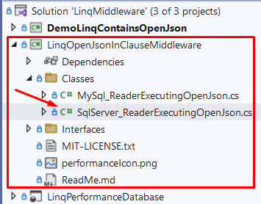
If you want to customise the code, for example increase the chunking limit, you can do this in the SqlServerReaderExecutingOpenJson class, by setting the constant MINIMUM_ITEM_SIZE.
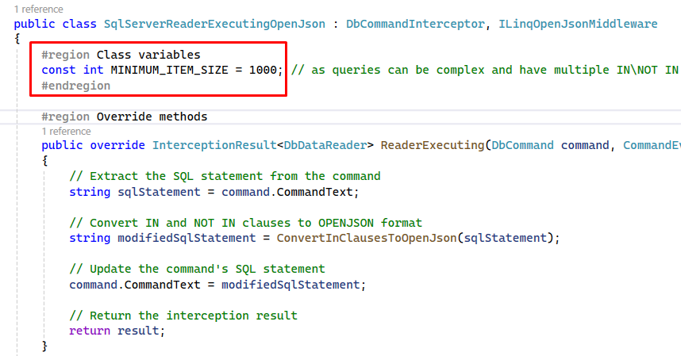
To integrate the SqlServerReaderExecutingOpenJson class into your project, simply copy the class form the LinqOpenJsonInClauseMiddleware project, renaming the Namespace in the class to match your project Namespace. Then, you can edit the SQL that gets generated to match your needs.

Edit Entity Framework Core Settings to Call Custom Interceptor Middleware
You can configure the SqlServerReaderExecutingOpenJson class, to be included in your project in two ways – choose which best suits your project.

Program.cs Class
- By adding the namespace using LinqOpenJsonInClauseMiddleware.Classes; to your project
- Adding the line of code options.AddInterceptors(new SqlServerReaderExecutingOpenJson to each of your dbContext related options (standard and factory contexts below).
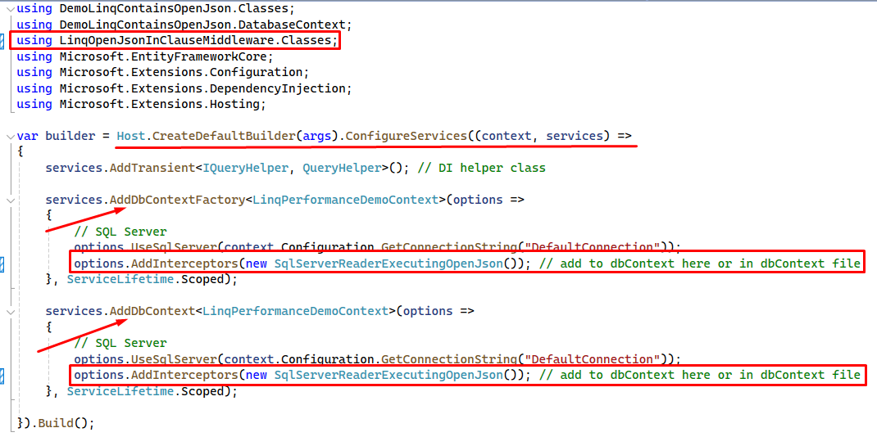

Your dbContext Class
- By adding the namespace using LinqOpenJsonInClauseMiddleware.Classes; to your project
- Adding the line of code options.AddInterceptors(new SqlServerReaderExecutingOpenJson to the OnConfiguring method’s options
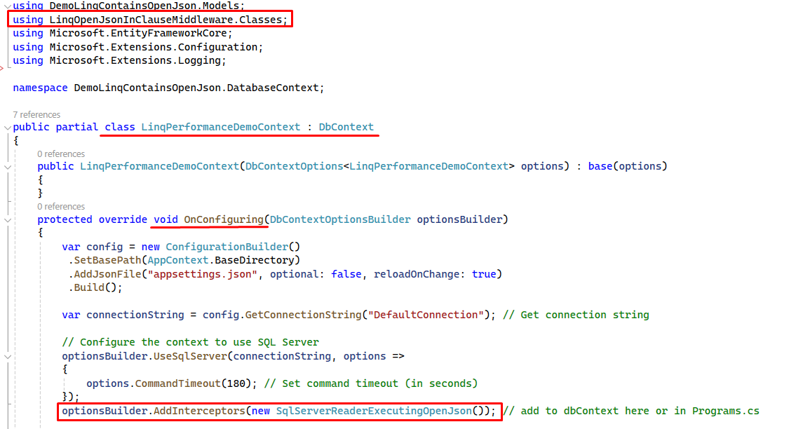

Interceptor Code Explanation

ReaderExecutingAsync | ReaderExecuting
In the override method below, you can see we intercept the SQL that is generated by LINQ (through the EF pipeline) and replace it with our OpenJson alternative SQL statement. We call out helper method ConvertInClauseToOpenJson to transpose the original EF SQL into our custom OpenJson oriented SQL statement.
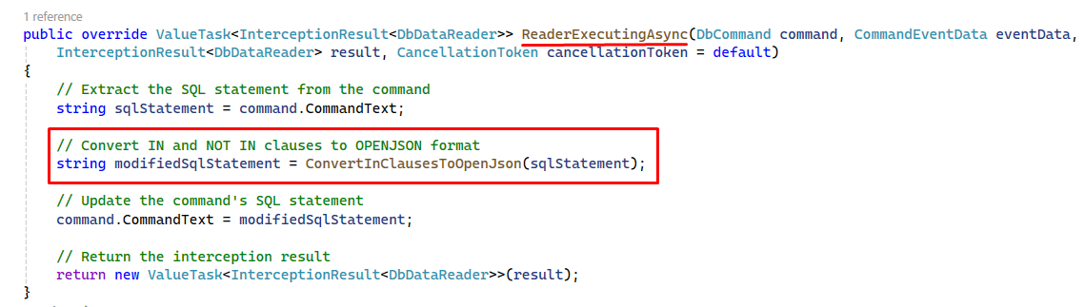

Helper Classes

ConvertInClauseToOpenJson
The ConvertInClauseToOpenJson method will parse out the IN\NOT IN clauses and then pass the values onto the ConvertToOpenJson method that will replace the existing SQL with the OpenJson SQL.
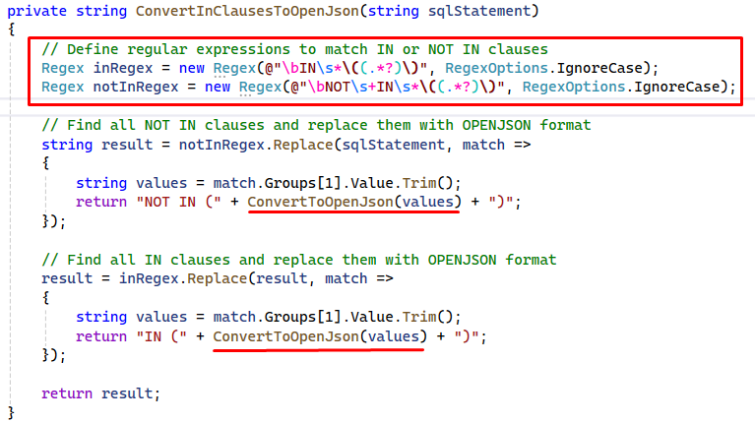

ConvertToOpenJson
The ConvertToOpenJson method will then determine if the values within the IN\NOT IN clause are integers\decimals or varchar related and build up the new OpenJson SQL related to that.
You can finally see the OpenJson statement being inserted to the SQL statement and returned to the parent IN\NOT IN clause.
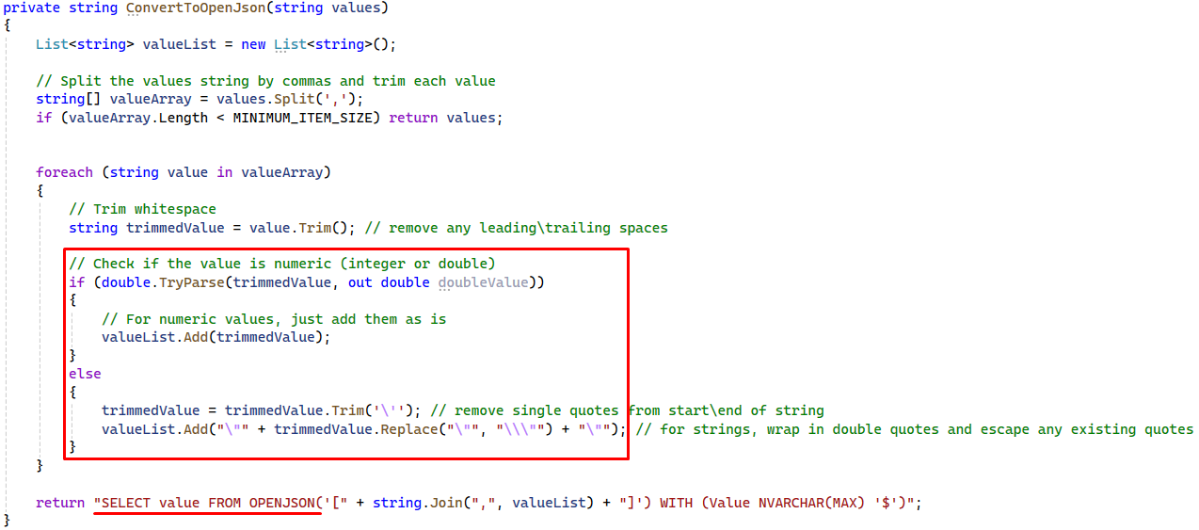

Examples of the Original EF SQL and the Generated OpenJson SQL
In the original SQL (with slimmed down values for brevity), you can see a standard IN clause and its values.
Then in the OpenJson generated SQL, you can see that the values are string related and that the OpenJson has correctly used the associated NVARCHAR datatype.
NB: The NOT IN clause didn’t get converted to OpenJson as its value count was less than 1k.

Varchar Example
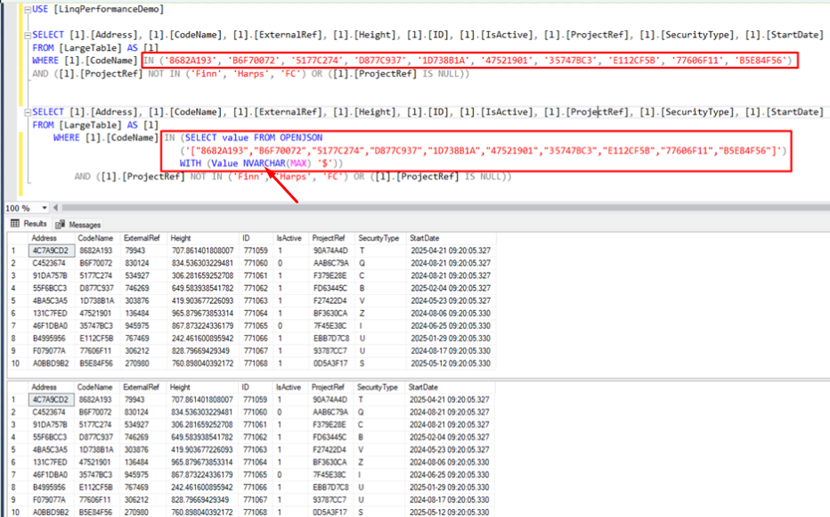

Integer Example
Below, you can see the equivalent for Integer related values within the IN clause, and the correct OpenJson datatype (Int) is associated with the query.
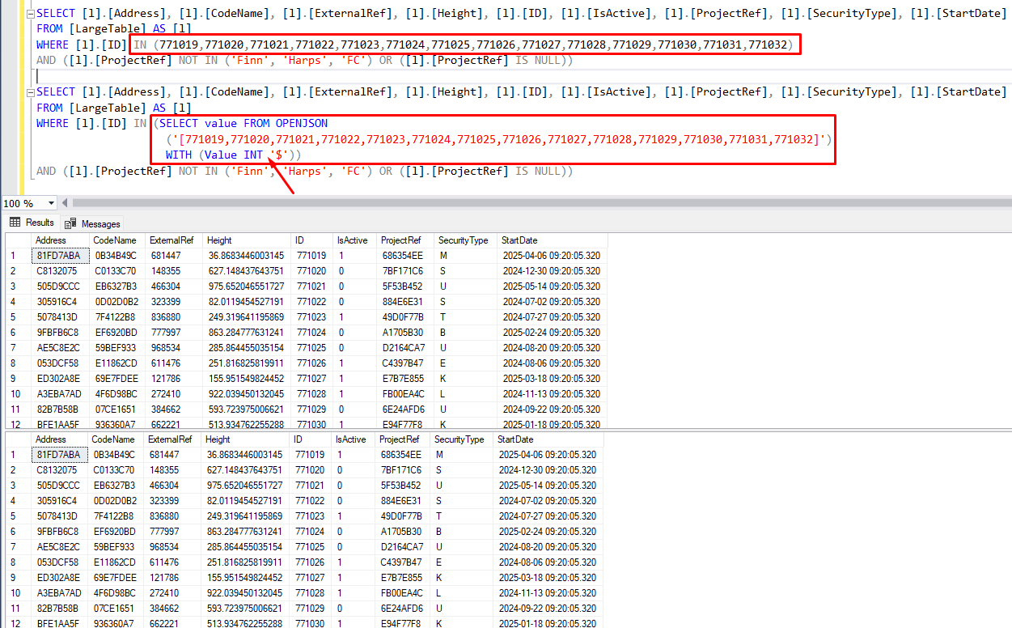

How to Collate Results Using Multithreading and ConcurrentBag
By using OpenJson you can get SQL Server to execute SQL statement with a larger IN\NOT IN clause. By default, EF Core 6\7 will execute with an IN clause of value count less than 20K, and this would be the total values for the whole statement (as your IN clause can be duplicated multiple times within a single EF generated SQL statement).
In previous projects, I have taken the approach to execute OpenJson queries based on the complexity of each query. I do this by limiting the size of the chunk to create a list of values.
Then loop this list, inserting the values into the OpenJson query and executing it, I use Parallel looping to take advantage of the multiple cores a server will have available, then I simply add the results to a (thread safe) ConcurrentBag.
You will find example code to execute the above scenario within the QueryHelper class in the DemoLinqContainsOpenJson project:
The code snippet below will:
- Define your chunk size (100K), this is the size of values you want to process at a time.
- Create the level of Parallelism to use.
- Retrieve 1 million values (integer Id’s)
- Create a chunked list (based on chunk size – 1 above).
- Run a query using a background Thread, add results to your ConcurrentBag
  - NB: Each Task will loop the appropriate number of times (chunk list size)
- Wait for all tasks to complete.
const int CHUNK_SIZE = 100_000;
var tskDatabaseQueries = new List<Task>(); // maintain the running background tasks
var parallelOptions = new ParallelOptions { MaxDegreeOfParallelism = 2 };
var resultBag = new ConcurrentBag<List<LargeTable>>(); // ConcurrentBag to hold all results safely

// mock a client that uses a cache of data to filter against - retrieve cached data (1M in each collection) - data will be duplicated in cases like char!
List<int> cacheInt = await Retrieve1MCacheIntegerAsync();
List<char> cacheChar = await Retrieve1MCacheCharAsync();
List<double?> cacheDouble = await Retrieve1MCacheDoubleAsync();
List<string> cacheString = await Retrieve1MCacheStringAsync();

// chunk data into 100K batches for looping
var chunkInt = cacheInt.Chunk(CHUNK_SIZE);
var chunkChar = cacheChar.Chunk(CHUNK_SIZE);
var chunkDouble = cacheDouble.Chunk(CHUNK_SIZE);
var chunkString = cacheString.Chunk(CHUNK_SIZE);

// make a linq call using Integer as the IN clause
tskDatabaseQueries.Add(Task.Run(async () =>
{
await Parallel.ForEachAsync(chunkInt, parallelOptions, async (sublist, cancellationToken) =>
{
var queryResult = await RetrieveIntegerChunkAsync(sublist);
resultBag.Add(queryResult);
});
}));

// make a linq call using Char as the IN clause
tskDatabaseQueries.Add(Task.Run(async () =>
{
await Parallel.ForEachAsync(chunkChar, parallelOptions, async (sublist, cancellationToken) =>
{
var queryResult = await RetrieveCharChunkAsync(sublist);
resultBag.Add(queryResult);
});
}));

// make a linq call using Double as the IN clause
tskDatabaseQueries.Add(Task.Run(async () =>
{
await Parallel.ForEachAsync(chunkDouble, parallelOptions, async (sublist, cancellationToken) =>
{
var queryResult = await RetrieveDoubleChunkAsync(sublist);
resultBag.Add(queryResult);
});
}));

// make a linq call using String as the IN clause
tskDatabaseQueries.Add(Task.Run(async () =>
{
await Parallel.ForEachAsync(chunkString, parallelOptions, async (sublist, cancellationToken) =>
{
var queryResult = await RetrieveStringChunkAsync(sublist);
resultBag.Add(queryResult);
});
}));

// Wait for all tasks to complete
await Task.WhenAll(tskDatabaseQueries);

Miscellaneous

Acronym
Abbreviation | Meaning
EF | Entity Framework
EFC | Entity Framework Core
SQL | Structured Query Language
TSQL | Transact Structured Query Language

